Basics

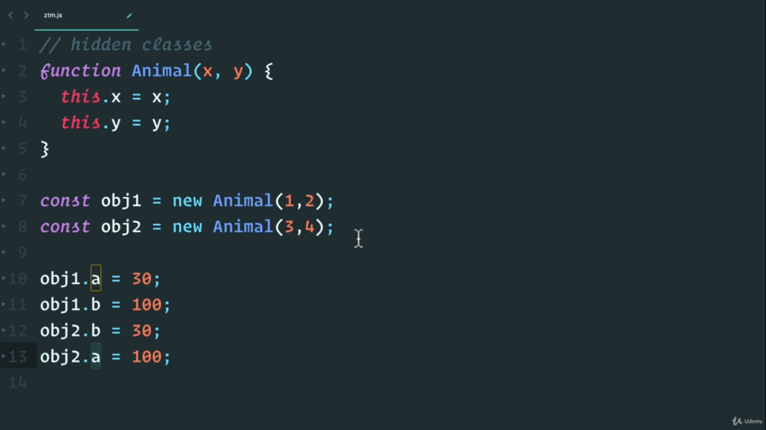
here we are assigning property a and b to obj1 and obj2 in diff order i.e if we write
obj1.a = 30
obj1.b = 100
then we should repeat same order while adding property for obj2
obj2.a = 100
obj2.b = 30

Garbage collection in js
1) var a = {name:”Akash”}
a = 5;
here object containing name get auomatically gets garbage collected

2) variables inside functions also gets garbage collected after that function is finished executing

Memory leaks
if we create a for loop with i=5; i > 0 ; i++ inside loop push item in array, we get memory leak (note that this is not stack overflow as there are no stack created here)

Three types of memory leaks
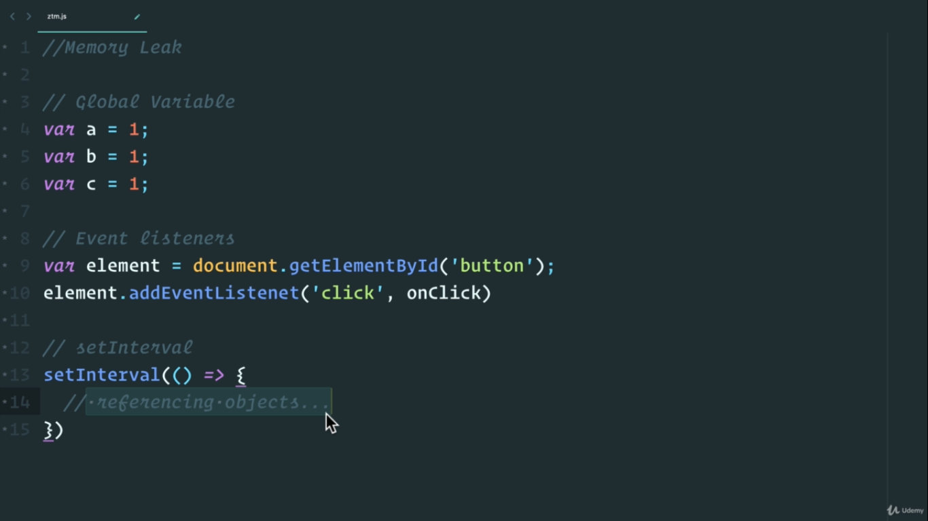

Javascript Single Threaded
1- Js has single call stack so it is single threaded
2 – Below diagram , web API comes with browser i.e chrome, firefox , edge etc
3 – All browser have their js engine implementation and js runtime which provides web api
4 -
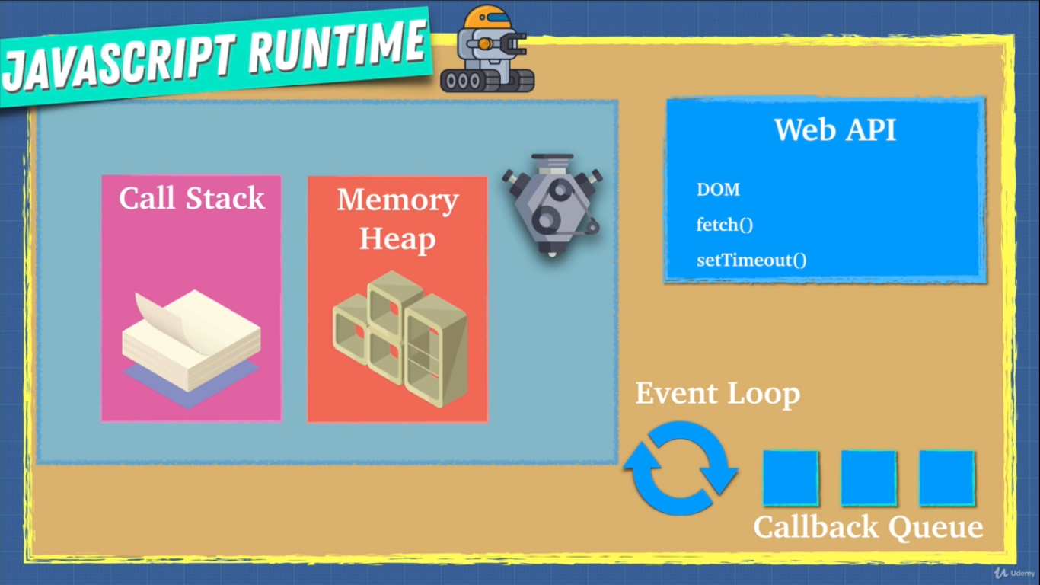

Scope
1- In call stack , base execution context is global and it is first thing in call stack
2 – global execution context gives us 2 things , global object and this, and they are same , we can prove this by creating a basic html file and link it with a js file which is empty , which will still have window i.e global and this deined

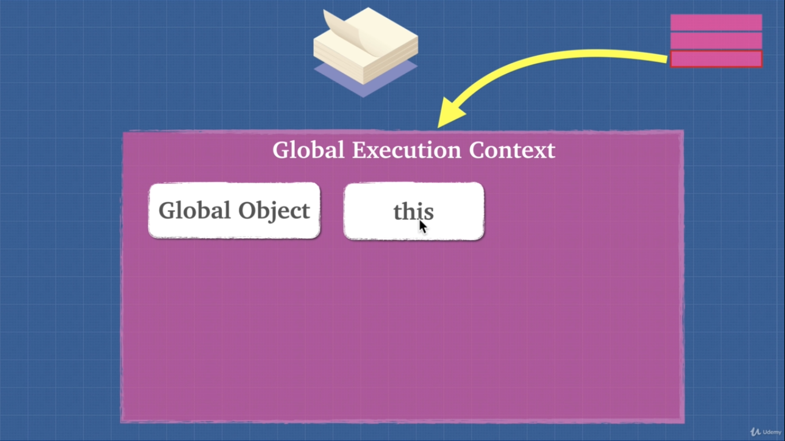

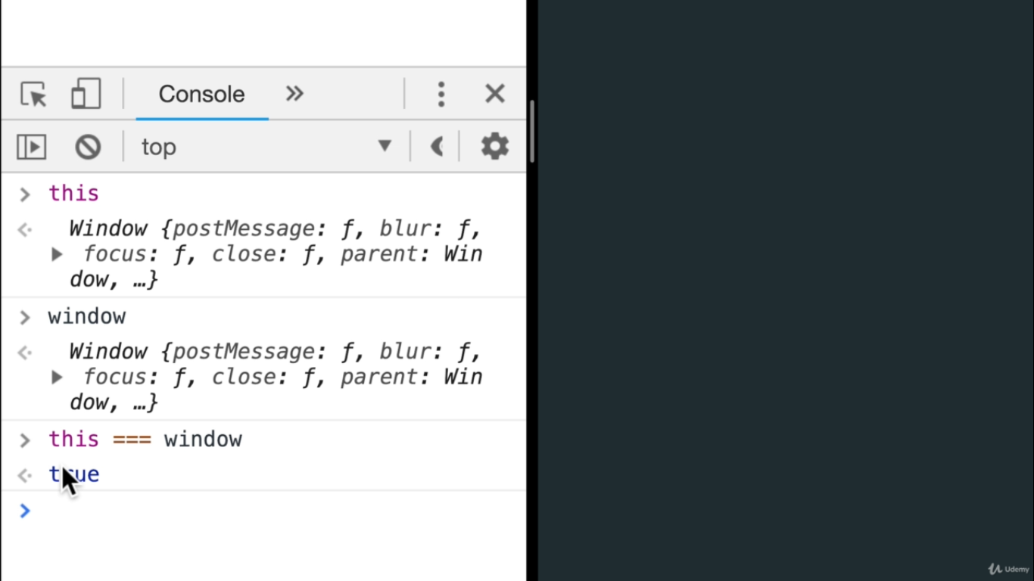

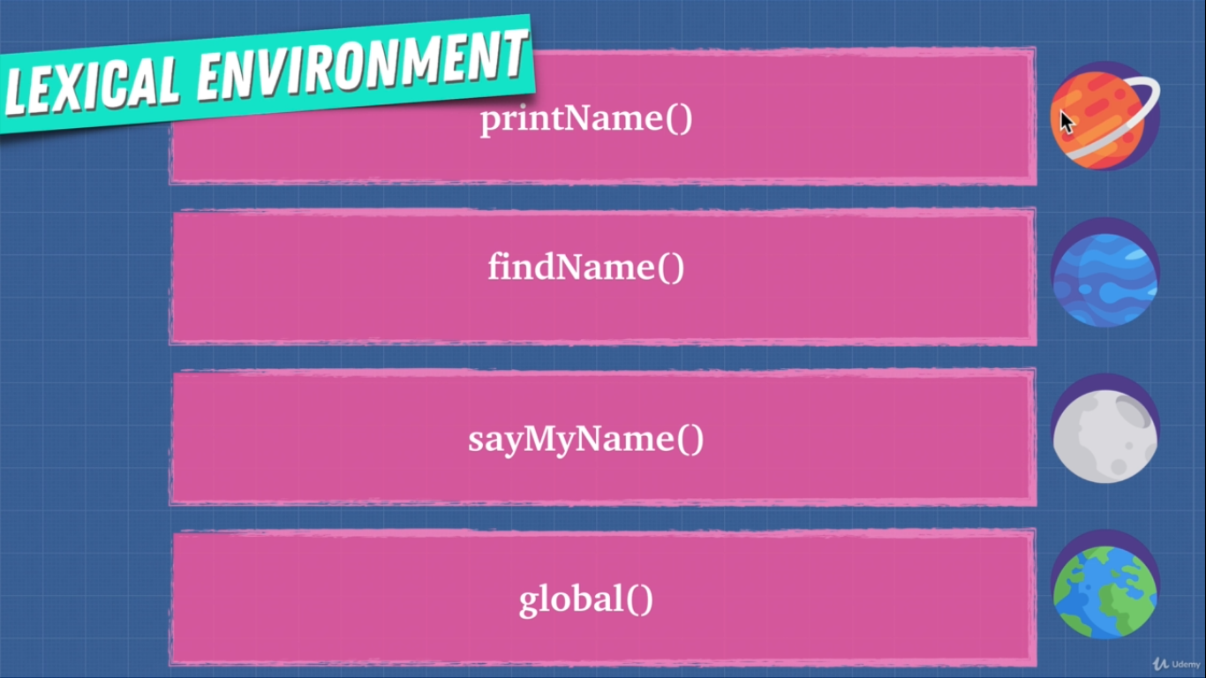

Lexical environment is like planets associated with each call stack execution context

Hoisting
1 – When we create execution context, there are 2 phases , i.e creation and execution, seperated by dotted white line in below image
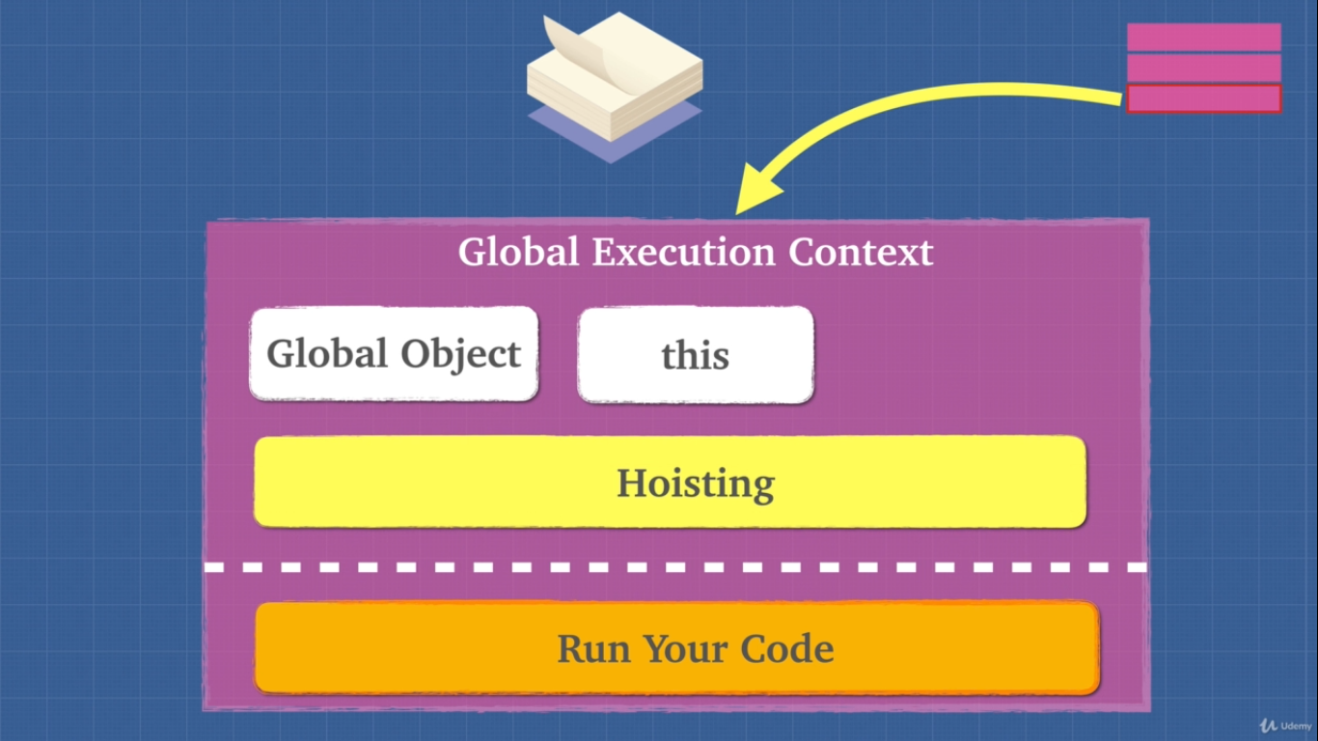

2 – In js , variables are partially hoisted and functions are hoisted (fully)
It means , see below program
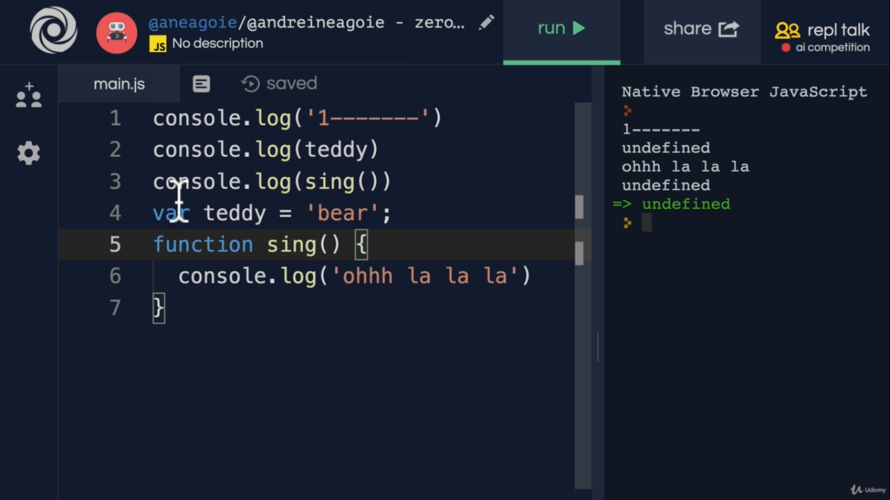
Here we log teddy before it was declared and we still get undefined , other languages might have given error as there is nothing called teddy but js reutrns undefined coz in creation phase,
teddy = undefined
so variables are partially hoisted

Function sing is created before execution phase starts so it gives correct op even if we use it before declaring it, so functions are fully hoisted

3 -
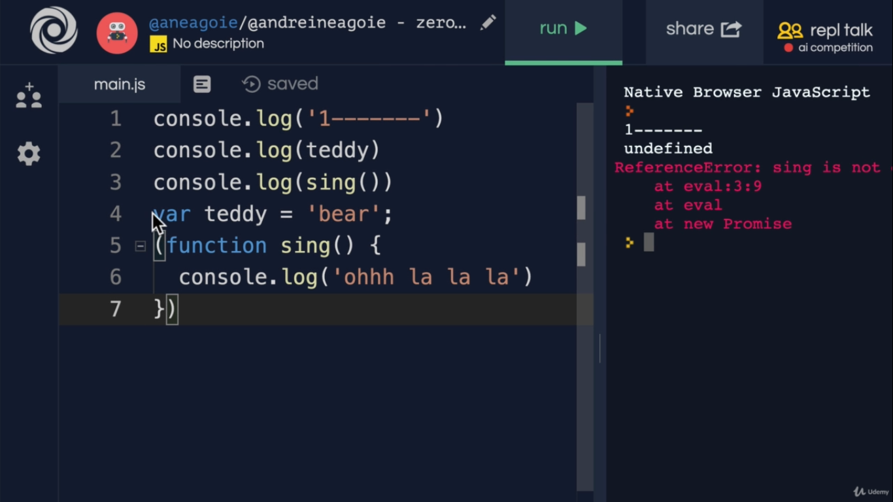
Whenever js engine see var keyword and function keyword , it hoist it
but above eg , we add brackets before function , so js engine sees bracket first and does not hoist it

Now if we use let or const, it wil give error as they are not var and hence not hoisted

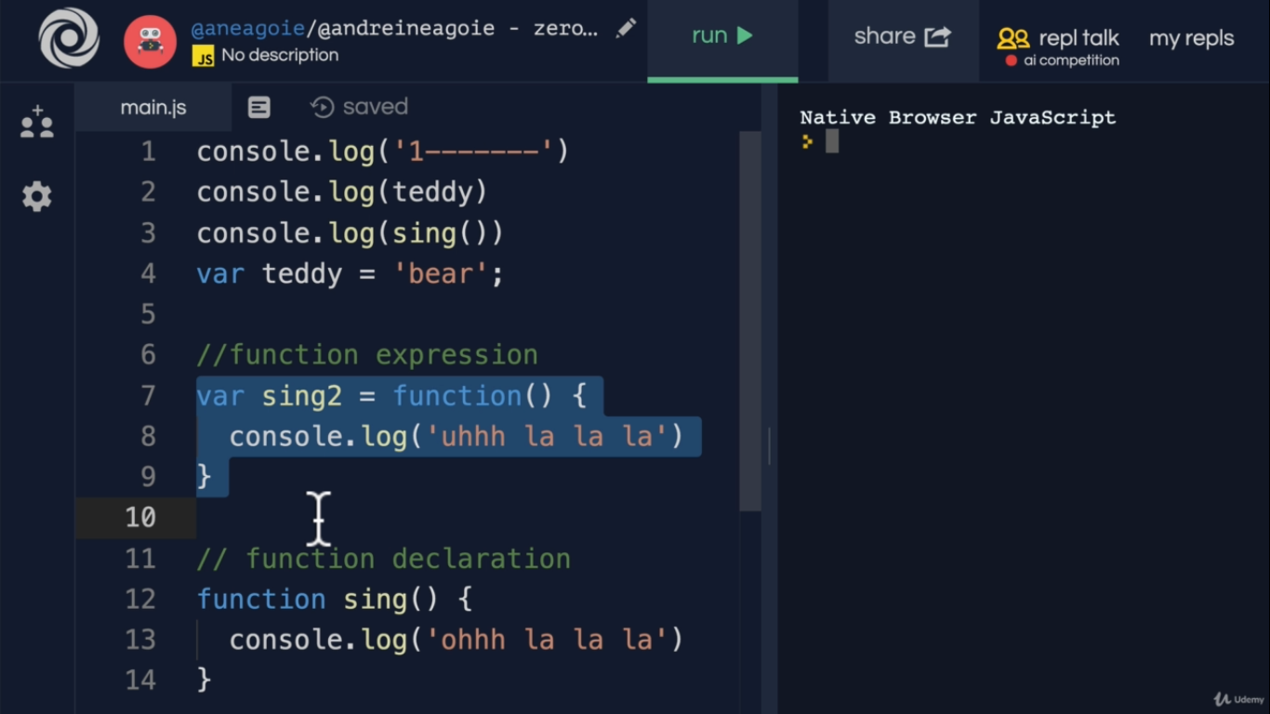
4 – Only function declaration is hoisted not function expression

Function Invocation
1 – When we create a execution context other than global execution context , we get

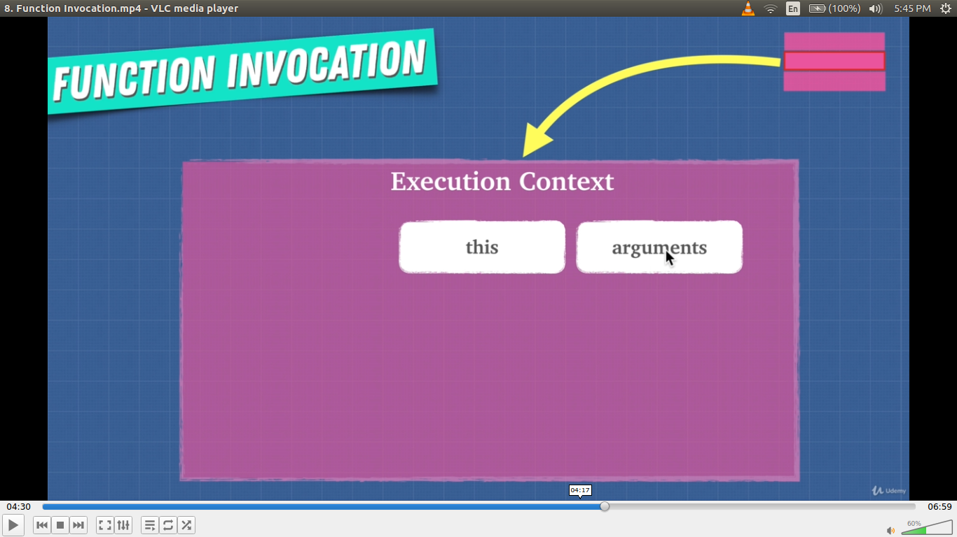

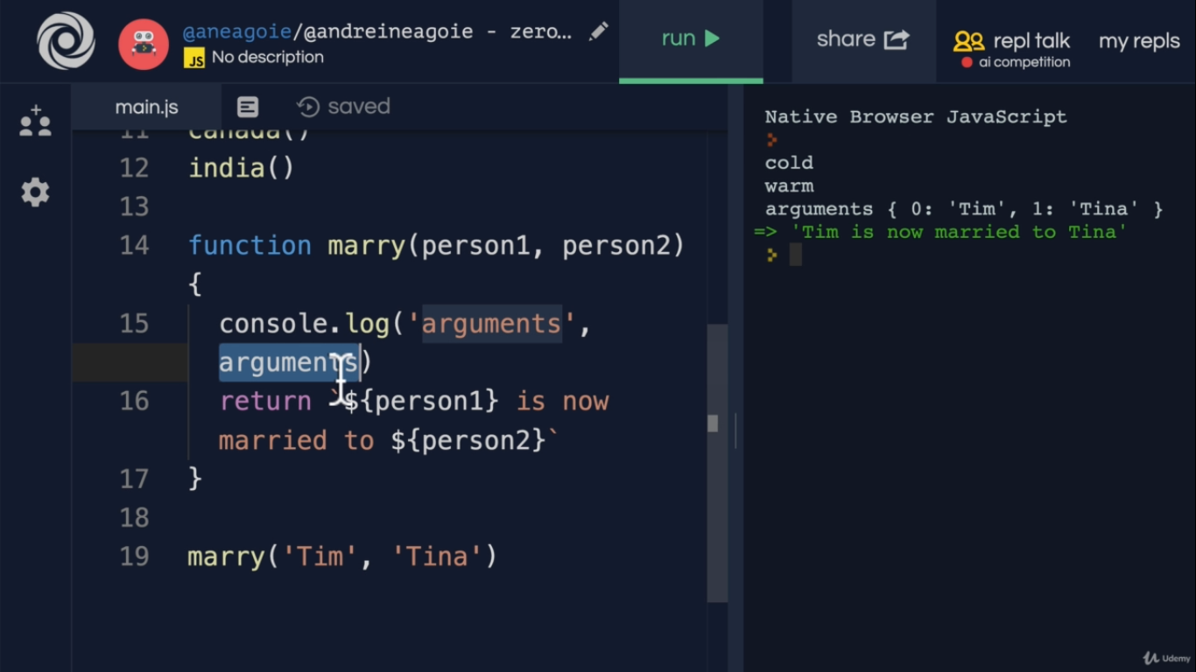

Each execution context has its own variable

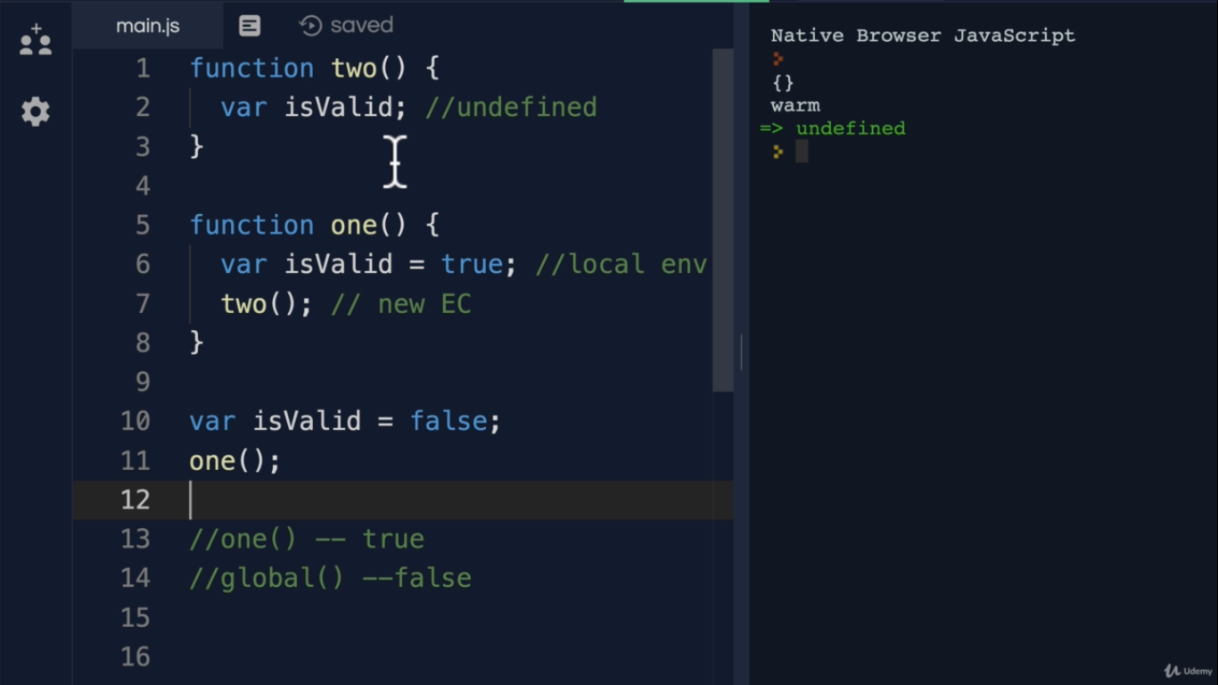

Function Scopes

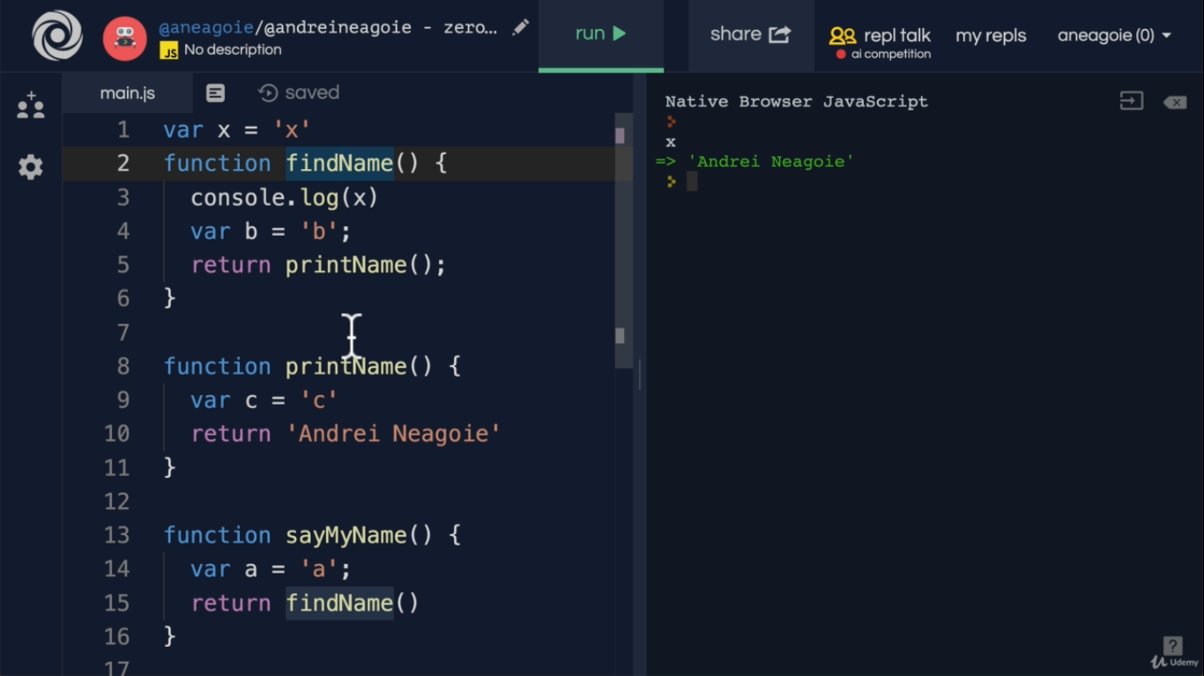
Here all the functions get hoisted to global execution context , hence var x is available everywhere
but in below case

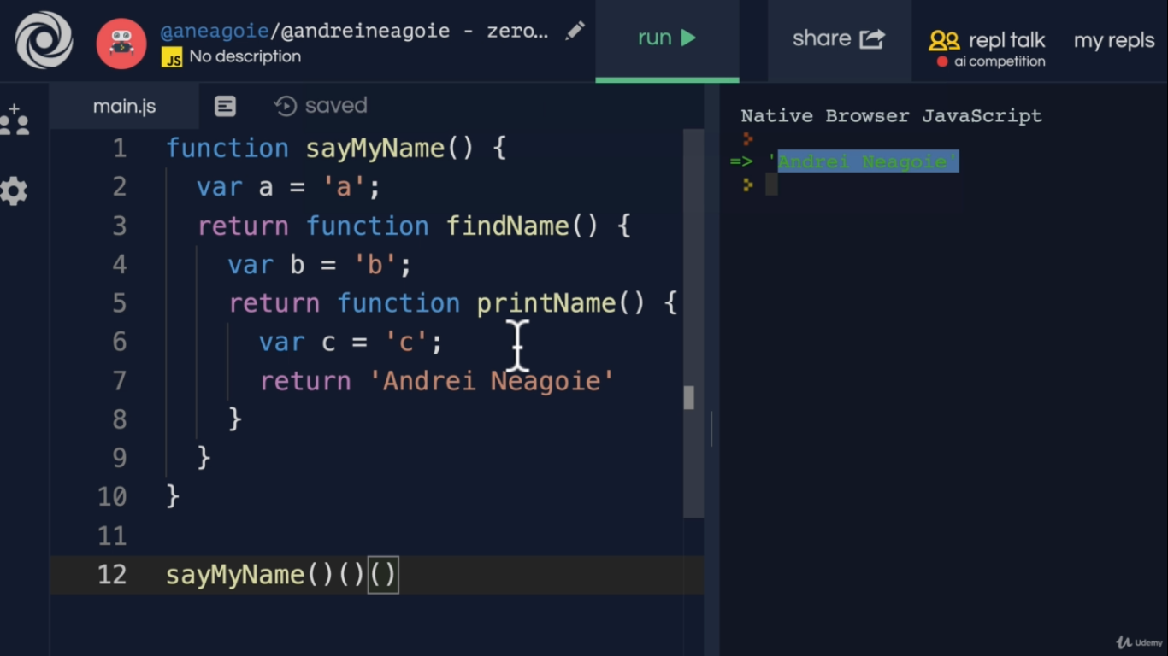
here functions are defined inside one another
so var a is available inside its inner functions and var b is available to its inner functions
Note – var a is accessable inside funcion printName

Variable leakage
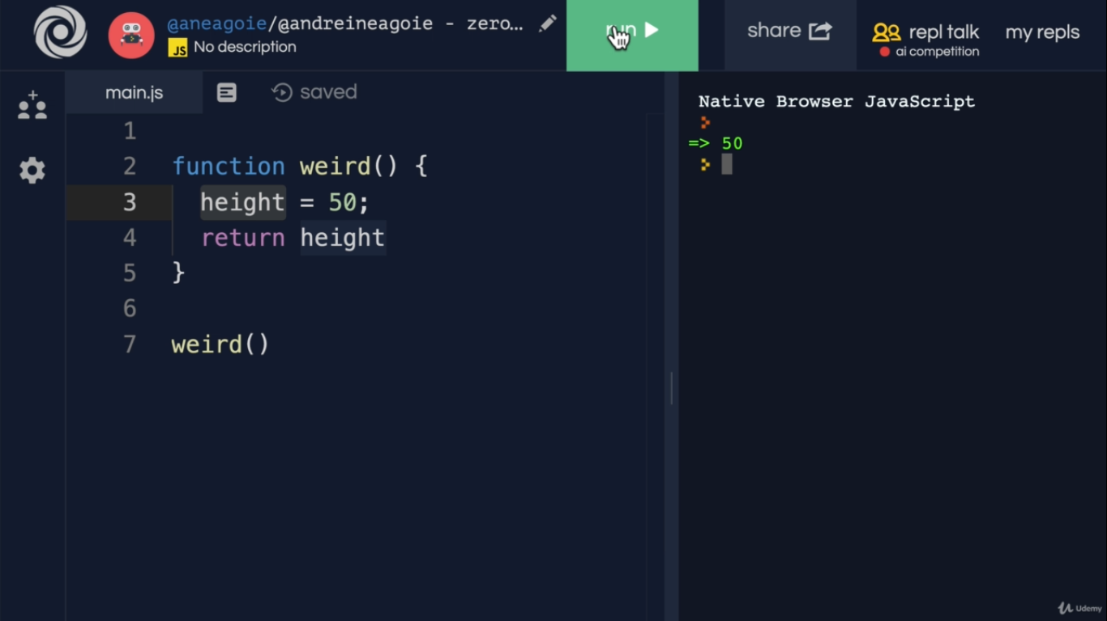
in above eg , we do not declare height using var or let or const , so it goes to parent scope and ask if parent has height var ? If it does not have , it will create one as undefined
hence height is a part of golbal environment
to avoid this , use strict

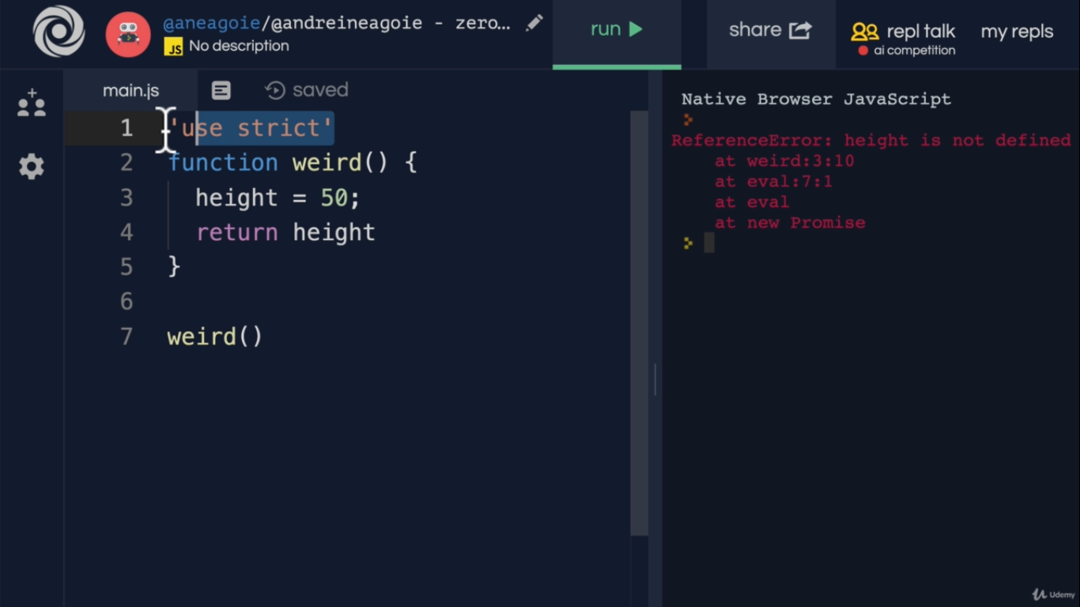

This

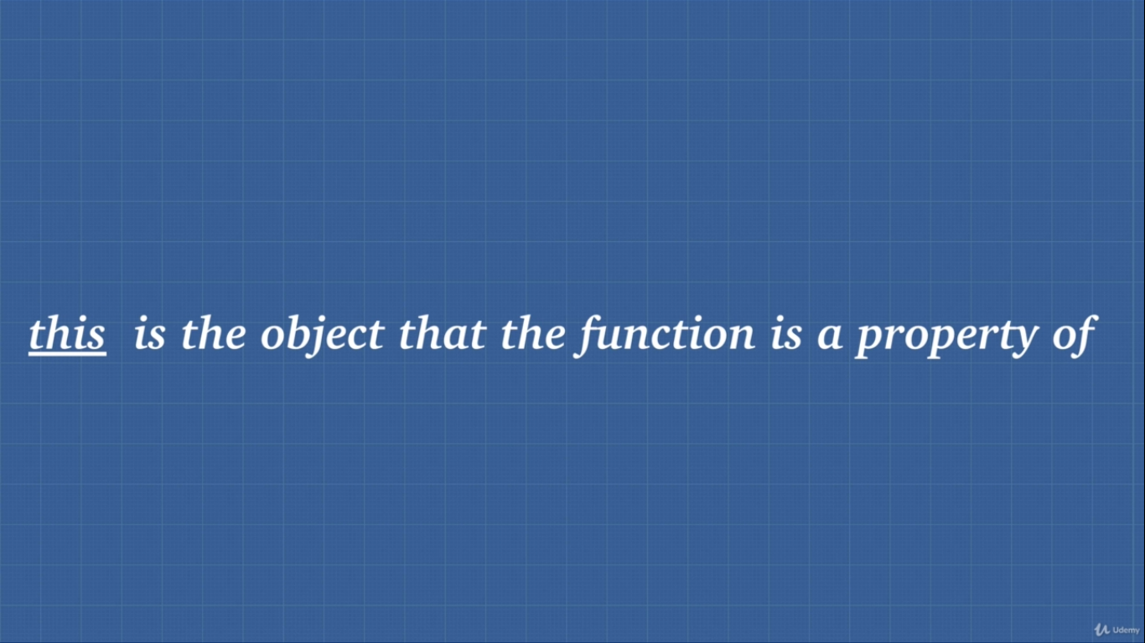
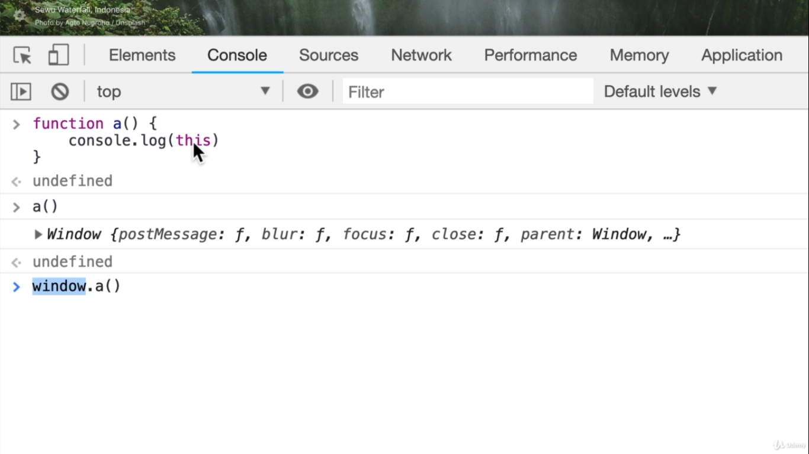

In above case function a is a property of window object

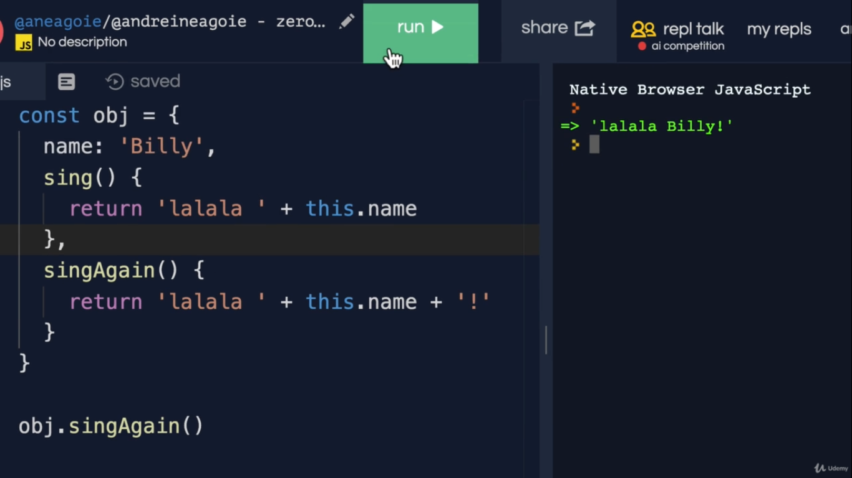

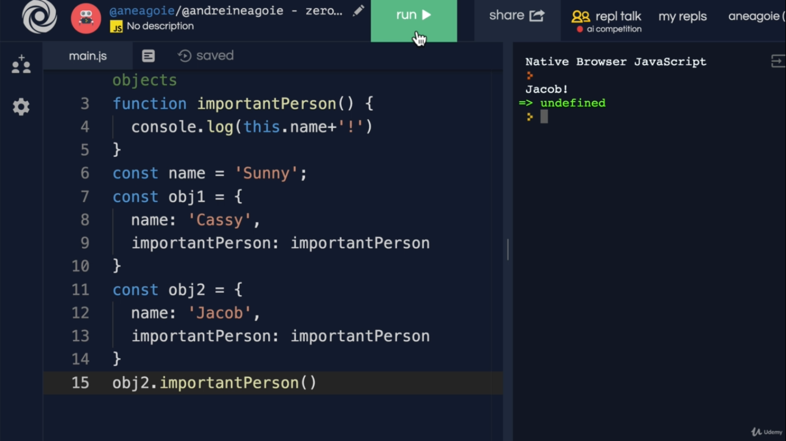

Call Apply and Bind

1 – Call
Under the hood all function invocation uses call
eg -
a() under the hood a.call()

we can use call method to bind “this” to another object

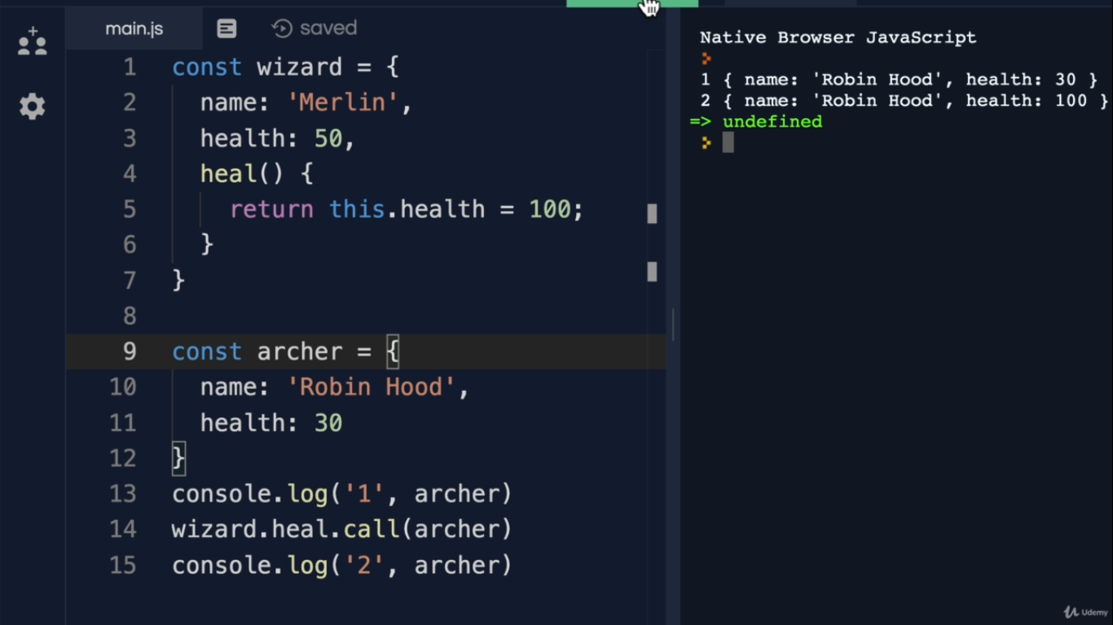

Apply – Second parameter of call is an arguments list seperated by comma
apply does the same thing as call but second parameter is array of arguments

Bind – Bind also does the same thing as call but it returns a function and we have to call that function


